DRAFT Texas Groundwater Protection Committee –
Groundwater Educational Outreach Plan
3rd Edition

September 2026

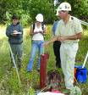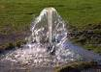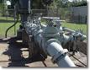

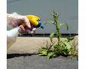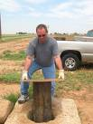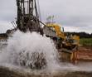

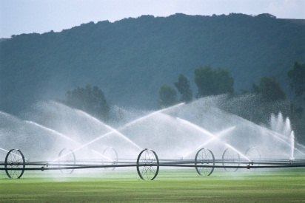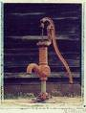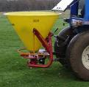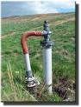

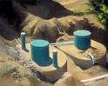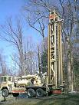

Table of Contents

Introduction 3
Background 4
Texas Well Owner Network 5
Marketing and Outreach 6
Additional FAQs 7

Introduction
The Texas Groundwater Protection Committee’s (TGPC’s) Public Outreach and Education (POE) Subcommittee published a Groundwater Educational Outreach Plan (“Plan”) in 2013 and an Implementation Strategy (“Strategy”) in 2007. The POE Subcommittee completed a number of items in the Plan and Strategy:
- Published 38 Frequently Asked Questions (FAQs) related to groundwater quantity, groundwater quality, septic systems, water wells, administrative entities, and publications in Fiscal Year (FY) 2024.

- Supported AgriLife Extension’s statewide water well screening events and Texas Well Owner Network.
- Provided TGPC brochures, magnets, giveaways, and maps to attendees at various groundwater-related conferences.
- Continued to display the “National Groundwater Awareness Week” poster in TCEQ Buildings A and F during National Groundwater Awareness Week.
- Reviewed and approved the POE Subcommittee Charge each fiscal year.

Background
In 2025, Activities and Recommendations of the Texas Groundwater Protection Committee – A Report to the 89rd Legislature (“2026 TGPC Legislative Report”) was published. On page 8, the 2026 TGPC Legislative Report included a recommendation related to education and outreach:

- “TGPC recommends that the legislature continue to support, through legislative appropriations and expanded program authority, as appropriate, the many programs which enable TGPC member agencies to protect groundwater quality. This support provides for groundwater protection activities through technology transfer, educational programming, research, quantification monitoring, and regulatory protection.”

In order to align its efforts with the 2025 TGPC Legislative Report’s recommendations related to the public outreach and education of landowners and local governments, the POE Subcommittee will focus on the following areas in this third edition of its Plan:
- Texas Well Owner Network (TWON)
- Social Media
- Additional FAQs

Texas Well Owner Network
Topic SMEs: Joel Pigg (AgriLife Extension) and John Smith (AgriLife Extension)

- The most important groundwater-related messages about this topic that need to be delivered are:
  - Water well owners are responsible for having the quality of their water well tested. Testing for fecal coliform bacteria and/or E. coli and nitrates should be done annually.
  - Importance of maintaining good records and well logs.
  - Monitor land use around the wellhead and protect the wellhead.
  - Plug abandoned water wells and properly cap functional water wells (if they are not being used).
  - Inspect and maintain existing septic systems.

- The most important audiences for this topic are:
  - Private water well owners
  - River Authorities
  - AgriLife Extension County Agents and USDA NRCS District Conservationists
  - Regional Water Planning Groups
  - State Legislators and their staff
  - GCDs

- Actions that would deliver these messages to these audiences include:
  - Develop TWON publications and Fact Sheets.
  - Offer TWON Well Informed sessions to the public: water well screening plus one-hour educational program.
  - Offer TWON Well Educated sessions to the public: water well screening plus six-hour educational program.
  - Maintain TWON website.
  - Use social media.
  - Develop YouTube videos (part 1 of 5, etc.).

- These messages can be regionalized by partnering with similar-minded local groups such as GCDs, the USGS Texas Water Science Center, and the statewide AgriLife Extension, SWCD, and USDA NRCS offices.
  - A contact person that the TGPC POE Subcommittee can work with should be identified in each of these organizations.
  - TWON Well Educated speakers include the TWON project team, GCD General Managers, watershed coordinators for Watershed Protection Plans (WPPs), River Authority laboratory directors, and may also include a water well driller in the future.
  - TWON has been developed as a statewide program.
  - Work with water well drillers.

Marketing and Outreach
- The goal of outreach is to further get groundwater information out to the public and increase public interactions.
- The ways we can do that are:
  - Updating/creating new marketing items such as stickers, magnets, etc.
  - Post meeting information, regular facts about groundwater, regular tips/tricks for protecting/conserving, etc. on the TCEQ social media pages
- Action items to create additional marketing tools for outreach:
  - Brainstorm ideas
  - Research marketing materials
  - Determine funds for marketing materials
  - Buy marketing materials
- The most important audiences for this topic are:
  - Texan citizens
  - Groundwater professionals

Additional FAQs
- Continue to focus on creating new FAQs based on current groundwater issues
- The goal of creating new FAQs is for the public to have a simple and straightforward way to access information on groundwater issues
- Action items for creating additional FAQs
  - Determine what FAQs would be beneficial to public
  - Select SMEs for each FAQ
- The most important audiences for this topic are:
  - Texan citizens

